**AIM: DESIGN A WEB APPLICATION FOR AN ORGANIZATION WITH REGISTRATION FORMS AND ADVANCED CONTROLS**

1. **Design online registration form for the participation of technical events (use HTML Controls, validation controls) and display all the data on the other page. Also design a layout using Master Page.**

**SOURCE CODE:**

**Site.master:**

<%@ Master Language="C#" AutoEventWireup="true" CodeFile="Site.master.cs" Inherits="SiteMaster" %>

<!DOCTYPE html PUBLIC "-//W3C//DTD XHTML 1.0 Strict//EN" "http://www.w3.org/TR/xhtml1/DTD/xhtml1-strict.dtd">

<html xmlns="http://www.w3.org/1999/xhtml" xml:lang="en">

<head runat="server">

<title></title>

<link href="~/Styles/Site.css" rel="stylesheet" type="text/css" />

<link href="https://cdn.jsdelivr.net/npm/bootstrap@5.0.2/dist/css/bootstrap.min.css"

rel="stylesheet" integrity="sha384-EVSTQN3/azprG1Anm3QDgpJLIm9Nao0Yz1ztcQTwFspd3yD65VohhpuuCOmLASjC"

crossorigin="anonymous" />

<script src="https://cdn.jsdelivr.net/npm/bootstrap@5.0.2/dist/js/bootstrap.bundle.min.js"

integrity="sha384-MrcW6ZMFYlzcLA8Nl+NtUVF0sA7MsXsP1UyJoMp4YLEuNSfAP+JcXn/tWtIaxVXM"

crossorigin="anonymous"></script>

<script src="https://cdn.jsdelivr.net/npm/@popperjs/core@2.9.2/dist/umd/popper.min.js"

integrity="sha384-IQsoLXl5PILFhosVNubq5LC7Qb9DXgDA9i+tQ8Zj3iwWAwPtgFTxbJ8NT4GN1R8p"

crossorigin="anonymous"></script>

<script src="https://cdn.jsdelivr.net/npm/bootstrap@5.0.2/dist/js/bootstrap.min.js"

integrity="sha384-cVKIPhGWiC2Al4u+LWgxfKTRIcfu0JTxR+EQDz/bgldoEyl4H0zUF0QKbrJ0EcQF"

crossorigin="anonymous"></script>

<script src="https://cdnjs.cloudflare.com/ajax/libs/angular.js/1.8.2/angular.min.js" integrity="sha512-7oYXeK0OxTFxndh0erL8FsjGvrl2VMDor6fVqzlLGfwOQQqTbYsGPv4ZZ15QHfSk80doyaM0ZJdvkyDcVO7KFA==" crossorigin="anonymous" referrerpolicy="no-referrer"></script>

<asp:ContentPlaceHolder ID="HeadContent" runat="server">

</asp:ContentPlaceHolder>

</head>

<body>

<form id="Form1" runat="server" method="post">

<div class="container" style="padding: 25px">

<div style="font-weight: bold; margin-block-end: 10px; text-align: center; border-style: solid">

<h1>SMART INDIA HACKATHON 2022

</h1>

</div>

<div style="float: left; width: 22%; height: auto; border-style: solid; margin-block-start: 15px; padding: 10px; margin-left: 10px; margin-right: 5px">

<asp:Menu ID="NavigationMenu" runat="server" CssClass="menu" EnableViewState="false" IncludeStyleBlock="false" Orientation="Vertical">

<Items>

<asp:MenuItem NavigateUrl="~/Default.aspx" Text="Home" />

<asp:MenuItem NavigateUrl="~/About.aspx" Text="About" />

</Items>

</asp:Menu>

</div>

<div style="float: left; width: 73%; border-style: solid; margin-block-start: 15px; margin-left: 5px; padding: 10px; margin-block-end: 10px">

<asp:ContentPlaceHolder ID="MainContent" runat="server" />

</div>

<p style="border-style: solid; text-align: center; font-weight: bold">

Copyright 2022 , Developed by Narender Keswani

</p>

</div>

</form>

</body>

</html>

**Default.aspx:**

<%@ Page Title="Home Page" Language="C#" MasterPageFile="~/Site.master" AutoEventWireup="true"

CodeFile="Default.aspx.cs" Inherits="_Default" %>

<asp:Content ID="HeaderContent" runat="server" ContentPlaceHolderID="HeadContent">

</asp:Content>

<asp:Content ID="BodyContent" runat="server" ContentPlaceHolderID="MainContent">

<div class="mb-3">

<label for="exampleFormControlInput1" class="form-label">Email address</label>

<asp:TextBox ID="email" runat="server" CssClass="form-control" placeholder="Enter your email"></asp:TextBox>

<asp:RequiredFieldValidator ID="RequiredFieldValidator1"

runat="server" ErrorMessage="Please enter your email"

ControlToValidate="email"></asp:RequiredFieldValidator>

<asp:RegularExpressionValidator

ID="regEmail"

ControlToValidate="email"

Text="Enter valid email id"

ValidationExpression="\w+([-+.']\w+)*@\w+([-.]\w+)*\.\w+([-.]\w+)*"

runat="server" />

</div>

<div class="mb-3">

<label for="exampleFormControlInput1" class="form-label">Select College:</label>

<asp:DropDownList ID="college" runat="server" CssClass="form-select">

<asp:ListItem Value="">Please Select</asp:ListItem>

<asp:ListItem>JHC </asp:ListItem>

<asp:ListItem>SPIT</asp:ListItem>

<asp:ListItem>VESIT</asp:ListItem>

</asp:DropDownList>

<asp:RequiredFieldValidator ID="RequiredFieldValidator9"

runat="server" ErrorMessage="Please select your college"

ControlToValidate="college"></asp:RequiredFieldValidator>

</div>

<div class="mb-3">

<label>Team Mentor Name:</label>

<asp:TextBox ID="tmn" runat="server" CssClass="form-control" placeholder="Enter your Team Mentor"></asp:TextBox>

<asp:RequiredFieldValidator ID="RequiredFieldValidator2"

runat="server" ErrorMessage="Please enter team mentor name"

ControlToValidate="tmn"></asp:RequiredFieldValidator>

</div>

<div class="mb-3">

<label>Team Member 1 Name:</label>

<asp:TextBox ID="tm1" runat="server" CssClass="form-control" placeholder="Enter your Team Member Name 1"></asp:TextBox>

<asp:RequiredFieldValidator ID="RequiredFieldValidator3"

runat="server" ErrorMessage="Please enter team member name 1"

ControlToValidate="tm1"></asp:RequiredFieldValidator>

</div>

<div class="mb-3">

<label>Team Member 2 Name:</label>

<asp:TextBox ID="tm2" runat="server" CssClass="form-control" placeholder="Enter your Team Member Name 2"></asp:TextBox>

<asp:RequiredFieldValidator ID="RequiredFieldValidator4"

runat="server" ErrorMessage="Please enter team member name 2"

ControlToValidate="tm2"></asp:RequiredFieldValidator>

</div>

<div class="mb-3">

<label>Team Member 3 Name:</label>

<asp:TextBox ID="tm3" runat="server" CssClass="form-control" placeholder="Enter your Team Member Name 3"></asp:TextBox>

<asp:RequiredFieldValidator ID="RequiredFieldValidator5"

runat="server" ErrorMessage="Please enter team member name 3"

ControlToValidate="tm3"></asp:RequiredFieldValidator>

</div>

<div class="mb-3">

<label>Team Member 4 Name:</label>

<asp:TextBox ID="tm4" runat="server" CssClass="form-control" placeholder="Enter your Team Member Name 4"></asp:TextBox>

<asp:RequiredFieldValidator ID="RequiredFieldValidator6"

runat="server" ErrorMessage="Please enter team member name 4"

ControlToValidate="tm4"></asp:RequiredFieldValidator>

</div>

<div class="mb-3">

<label>Team Member 5 Name:</label>

<asp:TextBox ID="tm5" runat="server" CssClass="form-control" placeholder="Enter your Team Member Name 5"></asp:TextBox>

<asp:RequiredFieldValidator ID="RequiredFieldValidator7"

runat="server" ErrorMessage="Please enter team member name 5"

ControlToValidate="tm5"></asp:RequiredFieldValidator>

</div>

<div class="mb-3">

<label>Team Member 6 Name:</label>

<asp:TextBox ID="tm6" runat="server" CssClass="form-control" placeholder="Enter your Team Member Name 6"></asp:TextBox>

<asp:RequiredFieldValidator ID="RequiredFieldValidator8"

runat="server" ErrorMessage="Please enter team member name 6"

ControlToValidate="tm6"></asp:RequiredFieldValidator>

</div>

<div class="mb-3">

<asp:Button ID="Button1" runat="server" Text="Register" CssClass="btn btn-primary" PostBackUrl="~/Default2.aspx" />

</div>

</asp:Content>

**Default2.aspx:**

<%@ Page Language="C#" AutoEventWireup="true" MasterPageFile="~/Site.master" CodeFile="Default2.aspx.cs" Inherits="Default2" %>

<asp:Content ID="HeaderContent" runat="server" ContentPlaceHolderID="HeadContent">

</asp:Content>

<asp:Content ID="BodyContent" runat="server" ContentPlaceHolderID="MainContent">

<div>

<asp:Label ID="Smsg" runat="server" Text="" CssClass="form-control"></asp:Label><br />

<asp:Label ID="Semail" runat="server" Text="" CssClass="form-control"></asp:Label><br />

<asp:Label ID="Stm" runat="server" Text="" CssClass="form-control"></asp:Label><br />

<asp:Label ID="Scollege" runat="server" Text="" CssClass="form-control"></asp:Label><br />

<asp:Label ID="Stm1" runat="server" Text="" CssClass="form-control"></asp:Label><br />

<asp:Label ID="Stm2" runat="server" Text="" CssClass="form-control"></asp:Label><br />

<asp:Label ID="Stm3" runat="server" Text="" CssClass="form-control"></asp:Label><br />

<asp:Label ID="Stm4" runat="server" Text="" CssClass="form-control"></asp:Label><br />

<asp:Label ID="Stm5" runat="server" Text="" CssClass="form-control"></asp:Label><br />

<asp:Label ID="Stm6" runat="server" Text="" CssClass="form-control"></asp:Label><br />

</div>

</asp:Content>

**Default2.aspx.cs:**

using System;

using System.Collections.Generic;

using System.Linq;

using System.Web;

using System.Web.UI;

using System.Web.UI.WebControls;

public partial class Default2 : System.Web.UI.Page

{

protected void Page_Load(object sender, EventArgs e)

{

if (PreviousPage != null)

{

ContentPlaceHolder placeHolder = (ContentPlaceHolder)PreviousPage.Master.FindControl("MainContent");

TextBox email = (TextBox)placeHolder.FindControl("email");

Smsg.Text = "<h3 style='color:green;'> You are successfully registered for SIH 2022 with following details: </h3>";

Semail.Text = "<b>Email :- </b>" + email.Text + "</b>";

DropDownList college = (DropDownList)placeHolder.FindControl("college");

Scollege.Text = "<b>College :- </b>" + college.Text + "</b>";

TextBox tm = (TextBox)placeHolder.FindControl("tmn");

Stm.Text = "<b>Team Mentor: </b>" + tm.Text + "</b>";

TextBox tm1 = (TextBox)placeHolder.FindControl("tm1");

Stm1.Text = "<b>Team Member 1: </b>" + tm1.Text + "</b>";

TextBox tm2 = (TextBox)placeHolder.FindControl("tm2");

Stm2.Text = "<b>Team Member 2: </b>" + tm2.Text + "</b>";

TextBox tm3 = (TextBox)placeHolder.FindControl("tm3");

Stm3.Text = "<b>Team Member 3: </b>" + tm3.Text + "</b>";

TextBox tm4 = (TextBox)placeHolder.FindControl("tm4");

Stm4.Text = "<b>Team Member 4: </b>" + tm4.Text + "</b>";

TextBox tm5 = (TextBox)placeHolder.FindControl("tm5");

Stm5.Text = "<b>Team Member 5: </b>" + tm5.Text + "</b>";

TextBox tm6 = (TextBox)placeHolder.FindControl("tm6");

Stm6.Text = "<b>Team Member 6: </b>" + tm6.Text + "</b>";

}

}

}

**About.aspx:**

<%@ Page Title="About Us" Language="C#" MasterPageFile="~/Site.master" AutoEventWireup="true"

CodeFile="About.aspx.cs" Inherits="About" %>

<asp:Content ID="HeaderContent" runat="server" ContentPlaceHolderID="HeadContent">

</asp:Content>

<asp:Content ID="BodyContent" runat="server" ContentPlaceHolderID="MainContent">

<h2>

About Us

</h2>

<p>

Hi,

I am Narender Keswani

</p>

</asp:Content>

**OUTPUT:**

**HOMEPAGE:**

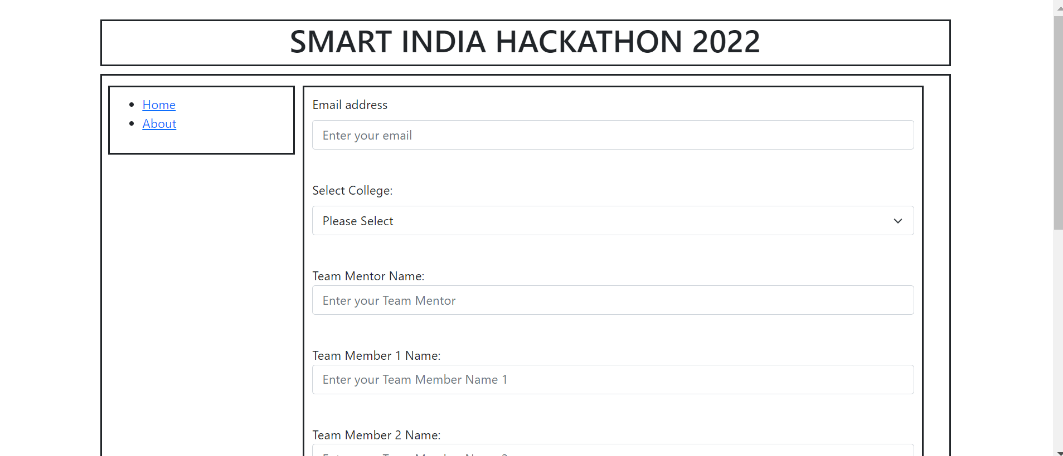

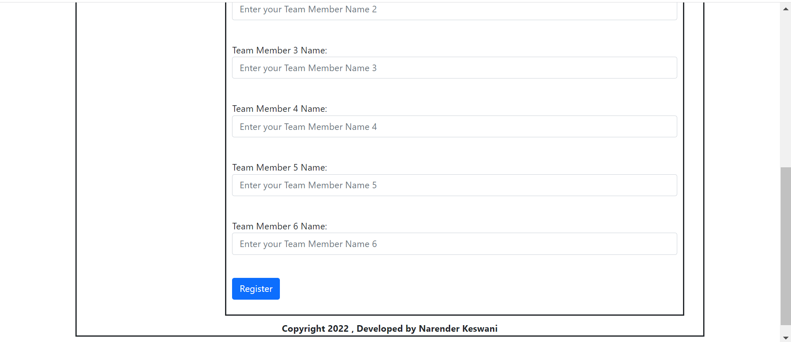

**ABOUT US PAGE:**

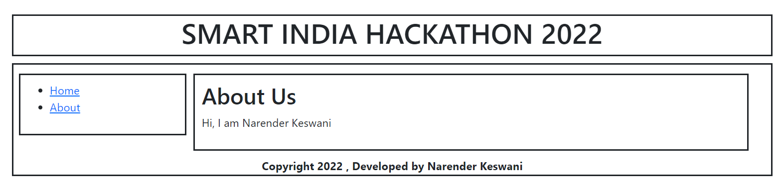

**VALIDATION:**

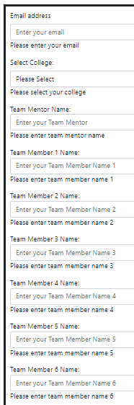

**FORM FILLING:**

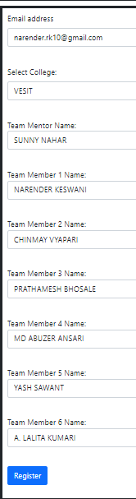

**Showing data on next page:**

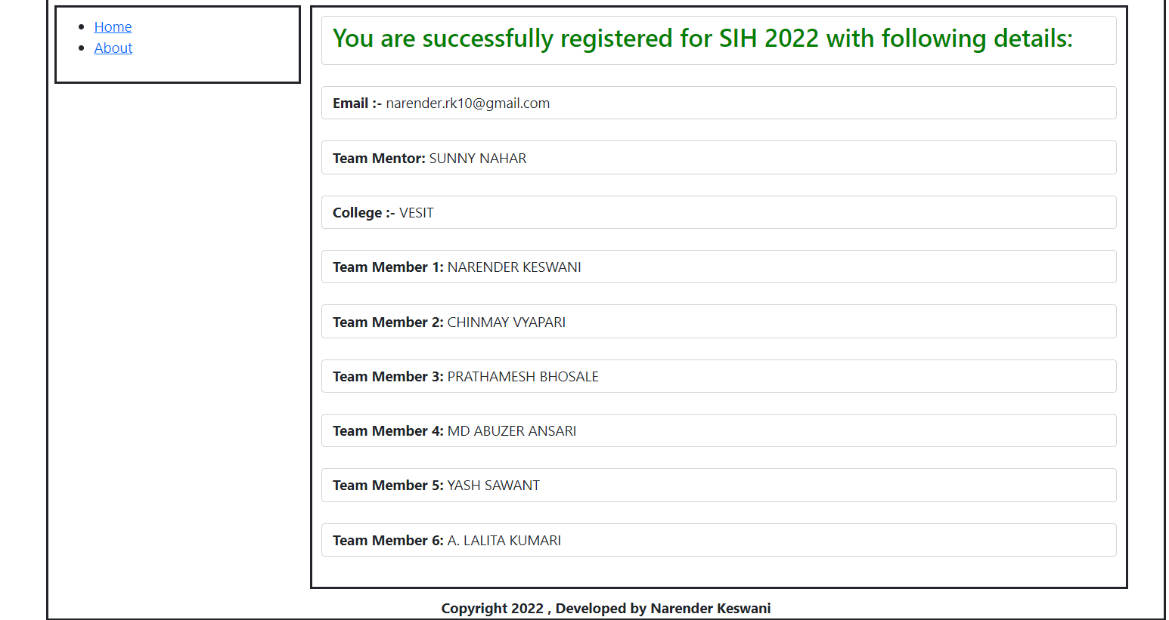

1. **Build a simple angular web application.**

**SOURCE CODE:**

<%@ Page Language="C#" AutoEventWireup="true" CodeFile="Angular.aspx.cs" Inherits="Angular" %>

<!DOCTYPE html>

<html>

<head>

<script src="https://cdnjs.cloudflare.com/ajax/libs/angular.js/1.8.2/angular.min.js"

integrity="sha512-

7oYXeK0OxTFxndh0erL8FsjGvrl2VMDor6fVqzlLGfwOQQqTbYsGPv4ZZ15QHfSk80doyaM0ZJdv

kyDcVO7KFA=="

crossorigin="anonymous" referrerpolicy="no-referrer"></script>

<link href="https://cdn.jsdelivr.net/npm/bootstrap@5.0.2/dist/css/bootstrap.min.css"

rel="stylesheet"

integrity="sha384-

EVSTQN3/azprG1Anm3QDgpJLIm9Nao0Yz1ztcQTwFspd3yD65VohhpuuCOmLASjC"

crossorigin="anonymous">

<script

src="https://cdn.jsdelivr.net/npm/bootstrap@5.0.2/dist/js/bootstrap.bundle.min.js"

integrity="sha384-

MrcW6ZMFYlzcLA8Nl+NtUVF0sA7MsXsP1UyJoMp4YLEuNSfAP+JcXn/tWtIaxVXM"

crossorigin="anonymous"></script>

</head>

<body ng-app="myApp">

<div>

<div class="container" ng-controller="groceryCtrl">

<h2>Groceries:</h2>

Add Item:

<input type="text" ng-model="addGrocery" />

<button class="btn btn-primary" ng-click="addItem()">Add</button>

<ul class="list-group">

<li class="list-group-item" ng-repeat="g in Groceries">{{ g }} </li>

</ul>

</div>

</div>

<script type="text/javascript">

angular.module('myApp', [])

.controller('groceryCtrl', function GroceryController($scope) {

$scope.Groceries = [];

$scope.addItem = function () {

$scope.Groceries.push($scope.addGrocery);

$scope.addGrocery = "";

}

});

</script>

</body>

</html>

**OUTPUT:**

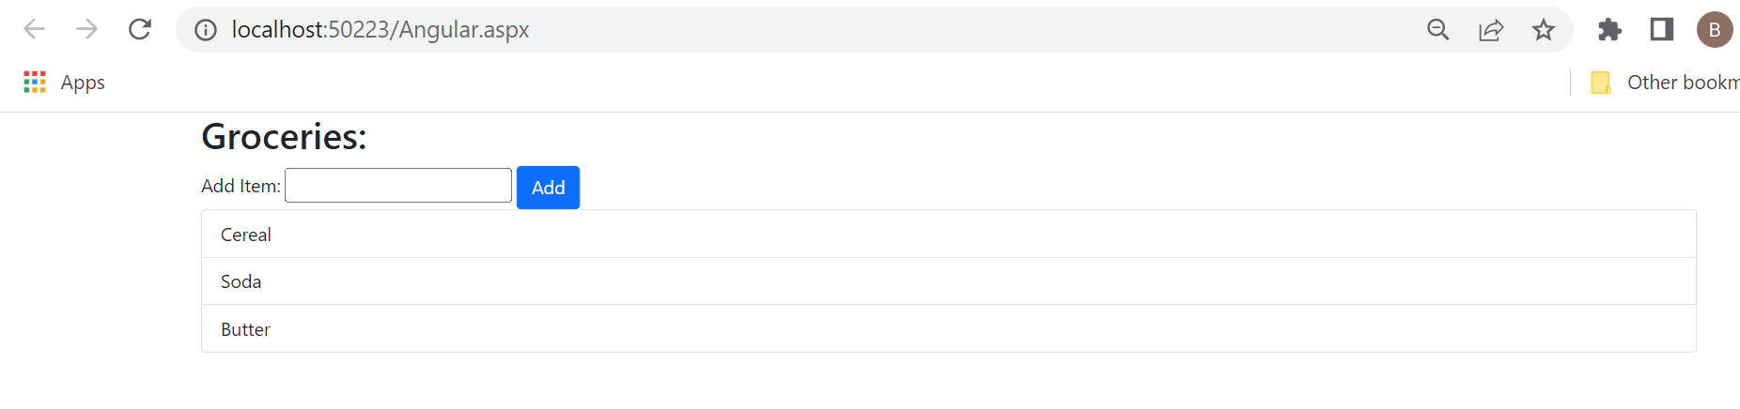

**CONCLUSION:**

From this practical, I have learned how to create web application in asp.net.